**Project Report**

**Mobile Application Development**

**Movi**

*An online movie ticket booking application*

**Prepared For**

*Dr. Muhamad Sadry Abu Seman*

**Prepared By**

* ***Muhammad Asyraf Bin Ibrahim 1310591***
* ***Jubaer Akhter 1430401***
* ***Shahrul Zaquan Amin 1422149***
* ***Syed Zafrul Huda 1433619***
* ***Muhammad Zafran Izat Bin Zahuri 1520313***

**Introduction**

For our project we have decided to develop a mobile application that will help people book their movie tickets according to their time , date and choice. On start, the application will prompt the user to sign up and then login. After that there will be a display page like a gallery full of movie options to choose for the user. After the user finds his choice he can select the preferred day and time to watch the movie in the cinema theater he/she can pay for the ticket through paypal. Once the payment is received the application will produce a digital ticket that will expire after one use.

**Problem description**

*Background of the problem*

In recent days, movie theaters are a great resource for entertainment. Most of the people often like to enjoy a part of their holiday watching a movie in a theater with family or friends. But most of the time it is difficult for many people to physically go to the theater having much time in hand to book their preferred seats earlier. Thus who can not make it within the time often has to cancel their plan or sit in undesired seats.

*Problem statement*

Almost all the movie ticket booking applications nowadays provide a generic serial number for tickets. Which are needed to show on the counter of the cinema hall later. Our application will get people rid of this manual procedure of standing in line. Also the system for storing the purchased tickets details are not upgraded that much which we are willing to solve.

**Project Objective**

To solve the problems stated above, we are coming up with a mobile application named ‘Movi’. It is basically an online movie ticket booking application for mobile devices. People who are on the rush with their works during weekdays will be able to use it for searching their preferred movies and book the tickets earlier of the show time date. the application will store the login details and the purchased ticket details in the firebase database ( for ticket details it’s still under process ).

**Project Scope**

*Scope*

Developing a interactive mobile application that will reduce the physical effort of people very easily. Movie lovers don’t have to wait long standing in lines no more. They can purchase their tickets directly from their smartphones by installing this app.

* User has to sign up and login using their Gmail account in this app for their future preferences.
* A home page containing the list of movies which can be scrolled.
* After selecting a movie the app will prompt a window asking the user to select his/her preferred day and time for the show.
* the pop up window will be extended to full screen if pulled over and will close if pulled down.
* the details of the movie and the poster will change position and align with the screen as the pop up window size changes.
* touching back drop will cause the pop up to close.
* Before the final phase of booking the application will prompt a window asking the user to pay for the tickets through paypal.
* The user needs to fill up the payment form with his/her credentials.
* Once the payment is received, there will be a pop out window with a digital ticket with confirmation bar code for the booked tickets.
* Once the QR code is scanned, the movie and seat details will appear on the screen and the QR code will expire.
* the application will be connected with firebase database system.
* it will store the login details for each user on the database and retrieve from it every time the user logs in again.
* after the ticket is purchased the details for each specific ticket will be stored in the database, and the details will be retrieved by scanning the particular barcode that was generated during the purchase

*Targeted user*

We are hoping that our app, Movi will be useful to people of all ages specially between 15-35 years old. Because these people are mostly students and service officers who don’t have enough extra time rather than their work during week days. So this application will help them the most to plan a perfect weekend without any inconvenience.

*Specific platform*

We are developing this application using React-Native. It will be developed for Android mobile devices. we have used android studio for the coding. the project is connected with firebase database for saving the user and ticket detils. We may also need to use Flash for a flash screen for the application. we will be further working on the ios version as soon as we finish the whole project for android.

**Constraints**

The most significant constraint for this project is time. We had to learn so many things in a short period of time and then apply them in real life. Developing a mobile application is really a time consuming process specially for beginners like us. There are so many things that are needed to built up from the scratch and for that we really need to have clear knowledge about every aspect of react-native. and another problem we faced was connecting the project with the firebase database. it was ok until we were just adding the data directly inside the code to generate the movie suggestions and confirmation code upon purchasing. but when it was time to store the data, login details and ticket details in a database, for not having previous experiences it was really quite tough.

**Project Stages**

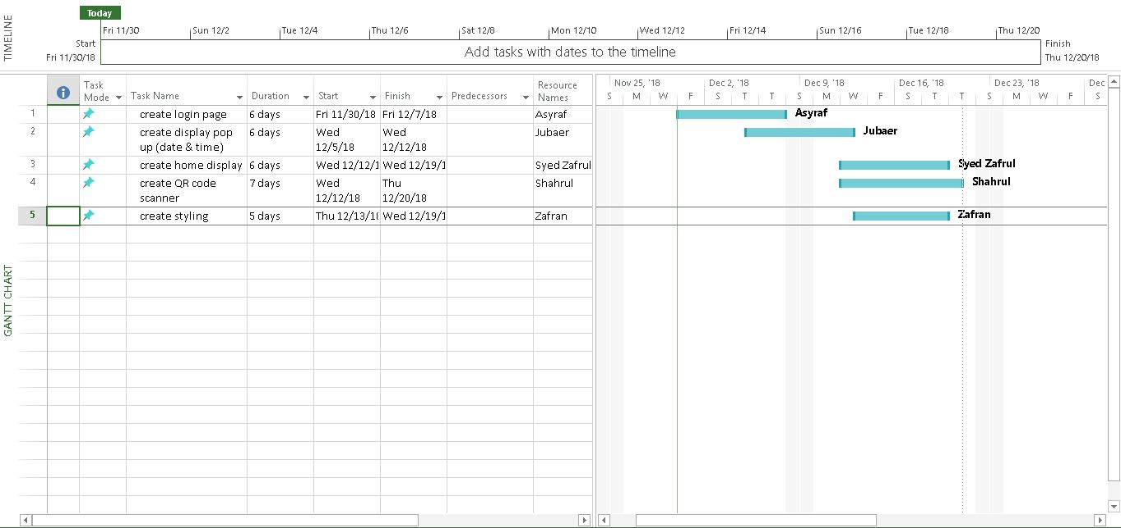

**Significance and Summary of the Project**

Technology nowadays has made the life of ours much easier. And mobile technology is one of the optimum powered gadgets that has been created ever. And almost everything that we understand as mobile technology are application based. There are so many things like a communication device through messenger apps, accessories like calculators and calendars, transportation services like Uber have become a part of our daily lives. We are hoping that our this application will help people save their precious times and also will refrain them from taking the hassles of going to movie theaters early and stand in lines. we are looking forward to work more with the project in future to develop the proper storage system for the user and ticket details. we also intend to upgrade the confirmation code generator to bar code generator which will retrieve the purchasing details once scanned (under construction).

**Data storage structure**

firebase database is used for storing login details of a user. the app will retrieve the data from the database every time a user logs in. also for every purchased tickets there will be unique details that will be saved immediately in the database after the user makes the payment. the app will generate an unique bar code for every ticket which will retrieve the details of the ticket as soon as scanned ( this part we are still working on).

**Google API**

for the application to search for latest movies and update the movie gallery automatically we intend to use The Movie Database (TMDb). this database offers not only movies but also tv shows and thousand of posters of them.